This project is a complete clone of Uber , which is a taxi booking iOS app. We have build this app using Native Objective- C for iOS and Native Java for Android . Some of the great features of the app are

Feature of User App :

1. Intro Video splash screen to give appealing look to the app.
2. Google api integration for autocomplete
3. Plotting of places to google map with distance and minutes calculation between routes.
4. One step and easy booking process.
5. Integration with Paypal and Stripe Payment gateway.
6. Support different rates for day and night.
7. Option to set cab types with rates from backend CMS .
8. Stylish animation between views with Facebook style slide menu.
9. Display all booking with scroll to load and clean UI.
10. Filters to sort booking’s on the basis of completed, pending booking etc.. Available on both User and Driver App.
11. Enable Auto refresh when driver accept job on driver arrival, journey begin , journey completed / dropped etc.
12. Support Push messages for all the status as well.
13. Live tracking Driver who are assigned for your booking.
14. Option to Cancel the Job till driver is not assigned.
15. Rate card screen with option to view all Taxi’s day and night rates.
16. 100% Native Objective C and shipped with full source code.
17. Support localization and Internationalization .
18. Support RTL Languages
19. Share ETA to Facebook and Twitter .

Feature of Driver App :

1. 3 Step registration form with all required field capture and validation done to make app ready to go live .
2. Facebook style sliding menu .
3. Option to set status available and unavailable .
4. Display all jobs with Scroll to load feature
5. Filters to sort jobs on the basis of completed, pending booking etc.. Available on both User and Driver App.
6. Support Socket.io Interface for tracking Driver . [ Available with customization ]
7. Support Socket.io Interface when new bookign is arrived and Phone will start beeping .[ Available with customization ].
8. Node.js Auto assigning of Driver for Jobs on the basis of availability of Driver avaibality , car type and nearest available driver using Robust Spatial GEO Queries [ Available with customization ].
9. Support Push messages to driver if app is in background. [ Available with customization ].
10. Calculating Tariff on the basis of Miles + Minutes require to travel .
11. Support localization and Internationalization .
12. Support RTL Languages .

Features in CMS :

Installation of Server side script :

1. Upload entire folder content of “CMS & Database” into your public html folder ( exclude db.sql file )
2. Then goto application folder -> config -> database.php and write database credentials according to following instructions.

**$db["default"]["hostname"] = "YOUR HOST NAME";**

**$db["default"]["username"] = "DATABASE USERNAME";**

**$db["default"]["password"] = "DATABASE PASSWORD";**

**$db["default"]["database"] ="DATABASE NAME";**

**Access cms from** [**http://ipaddress/cms**](http://ipaddress/cms)

**Access api from** [**http://ipaddress/web_service**](http://ipaddress/web_service)

3. Now go to application folder -> controllers -> web_service.php and find “send_mail” function. In this function you need to change following lines according to instructions.

**$mail->Username = "RECEIVER GMAIL EMAIL ID";**

**$mail->Password = "RECEIVER GMAIL ACCOUNT PASSWORD";**

**$mail->SetFrom('SENDER EMAIL ID', 'SENDER NAME');**

**$mail->AddReplyTo("REPLY EMAIL ID","REPLY NAME");**

Setup and Reskin Android :

1. First open android studio
2. Click Open an existing Android Studio project and Browse android project.
3. In order for us to point the Driver App to your server change api url string by going to app/src/main/java/come/texi/driver/utils/Url.java and change baseUrl variable to point to your server <ip address> .

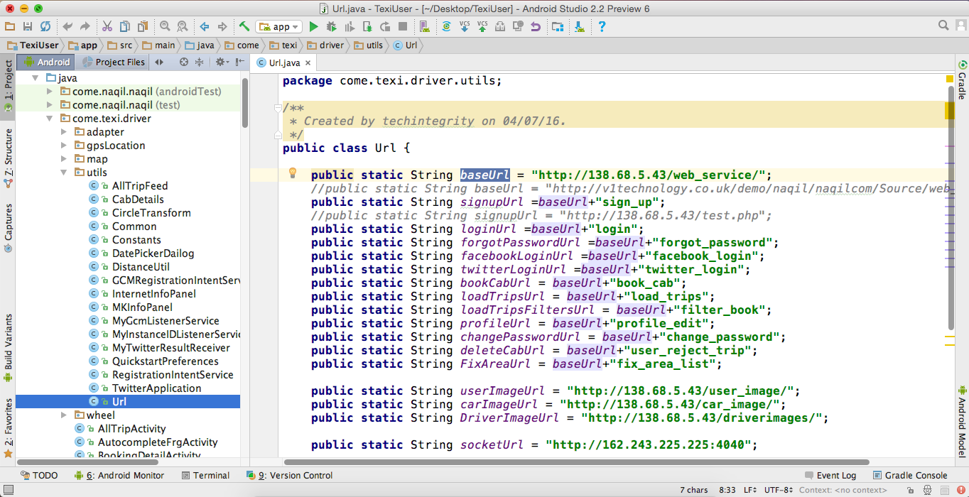

1. In order to change buttons text and background colours go to app/src/main/res/colors.xml

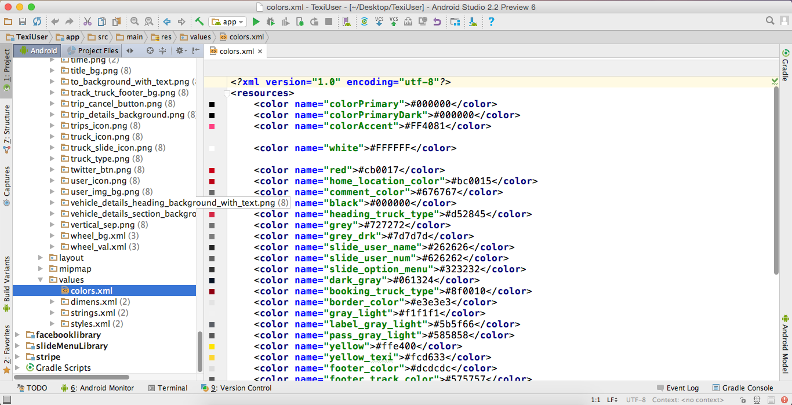

1. In order to change localization string or addign any new language to go app/src/main/res/values/strings.xml -- For English app/src/main/res/values-ar/strings.xml for English and Arabic , you can add more languages by adding xml files.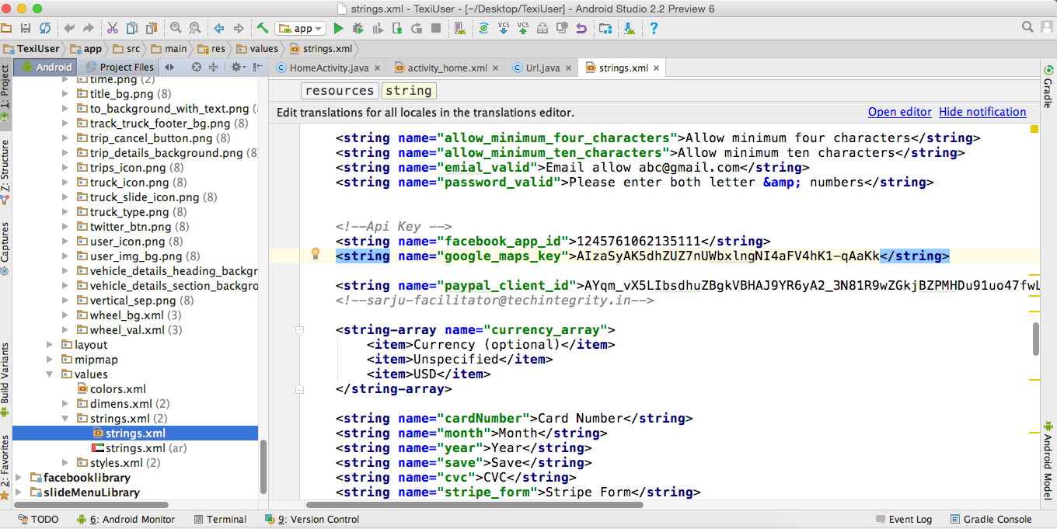
2. You can change your app-icons and other graphics which are kept in below folders.
   1. app/src/main/res/drawable-hdpi
   2. app/src/main/res/drawable-mdpi
   3. app/src/main/res/drawable-xhdpi
   4. app/src/main/res/drawable-xxhdpi
3. Now open User App in Android studio and in the first step we will change the url to point to our server . Lets do that by opening app/src/main/java/come/texi/utils/Url.java . and change “baseUrl” variable to change to your server iP-address.

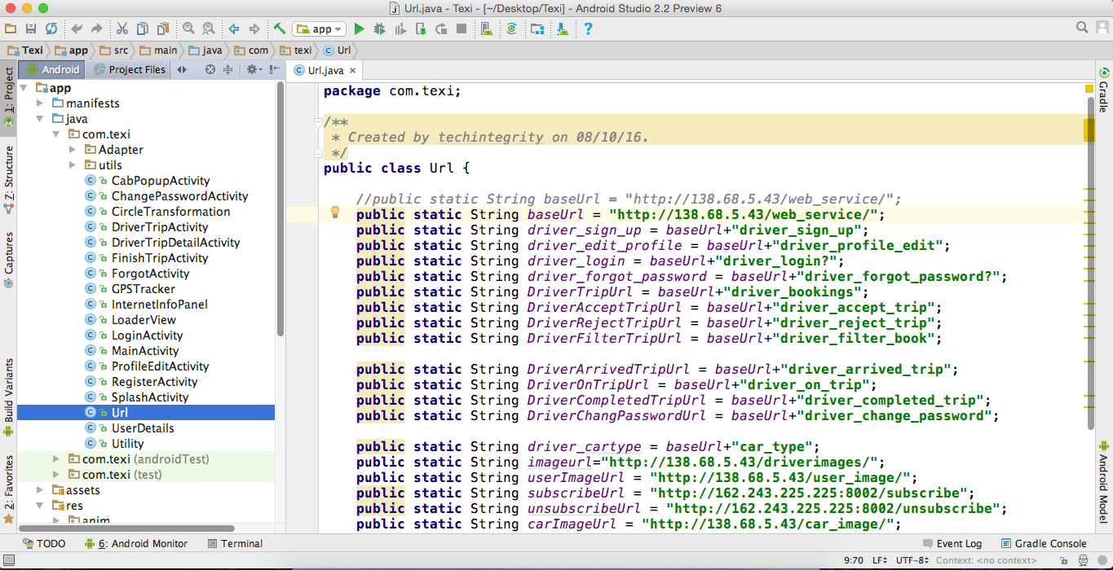

1. Configure Facebook App ID .
   1. Step 1 : Create Facebook App id by login to [**https://developers.facebook.com**](https://developers.facebook.com)and click Add a new app

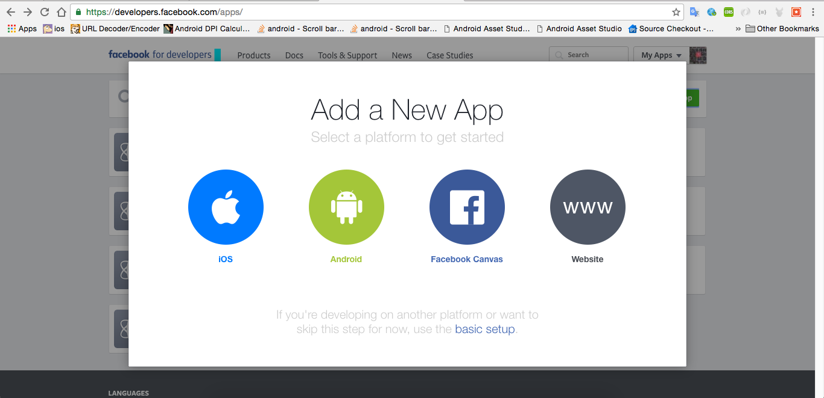

* 1. click android
  2. click skip and create app id

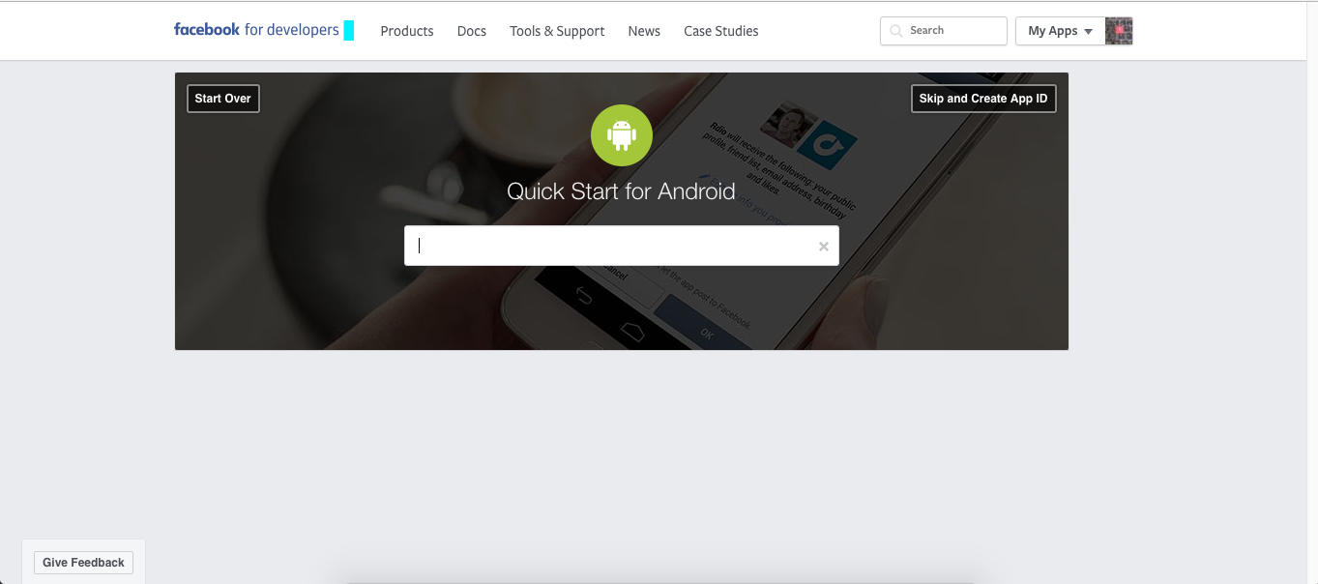

* 1. fill up this form with your relevant details .

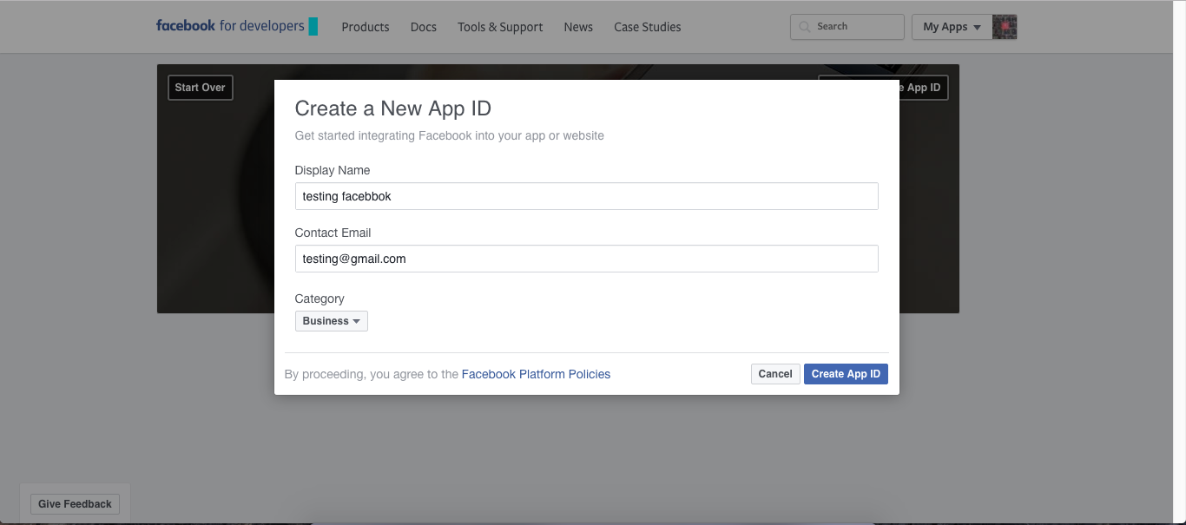

* 1. click dashboard

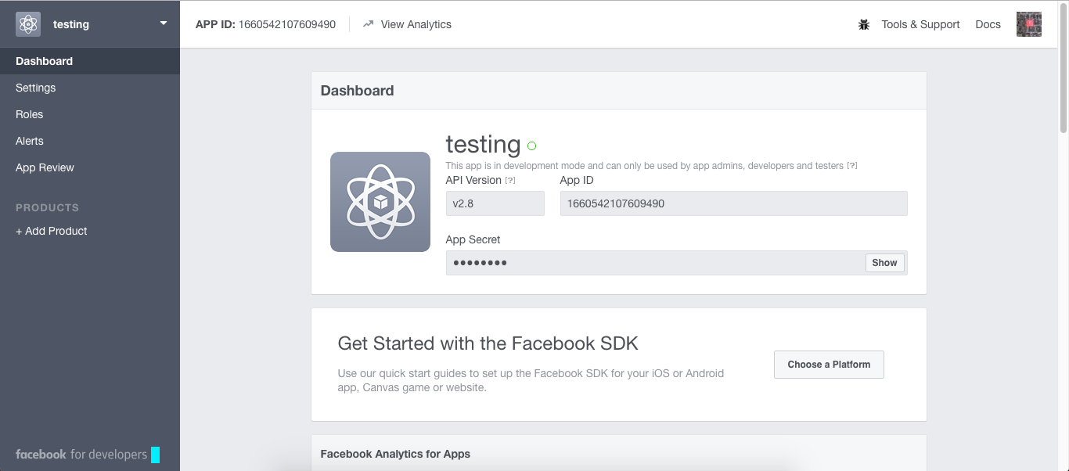

* 1. click add platform then open popup and select android and fill this form then click save change button.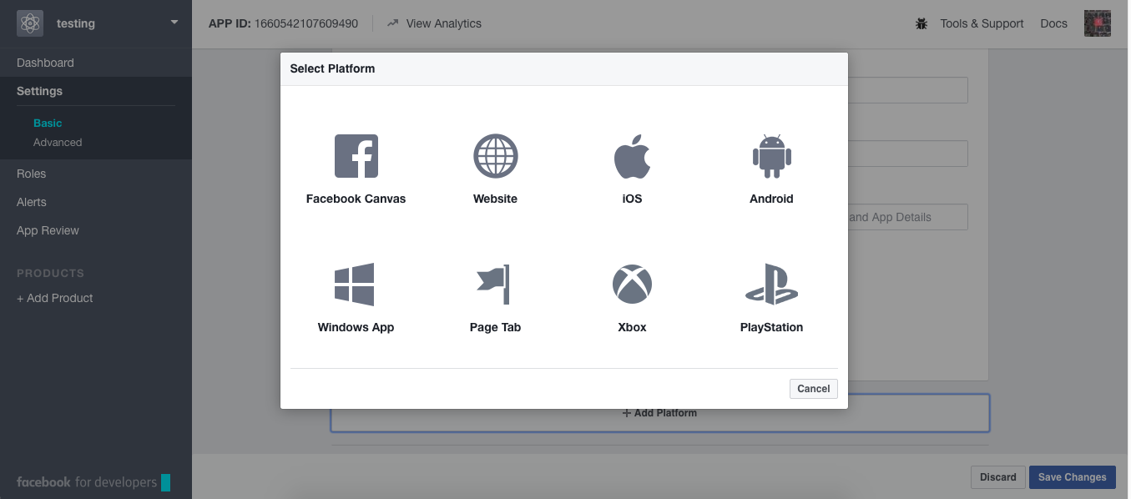
  2. create Hashes key for your computer and paste inside key hashes text box.

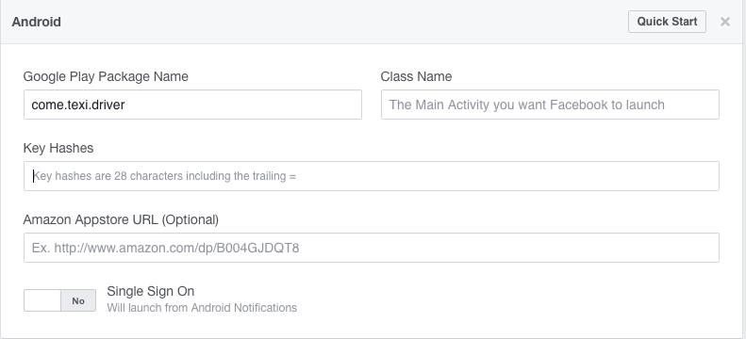

* 1. Click App Review and make testing public check yes

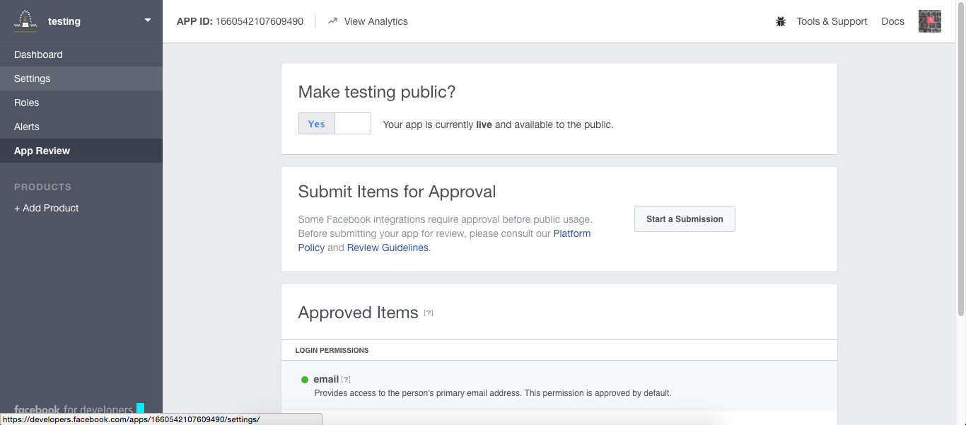

* 1. Click App Review and mack testing public check yes
  2. If all forms are filled up then app icon will turn GREEN

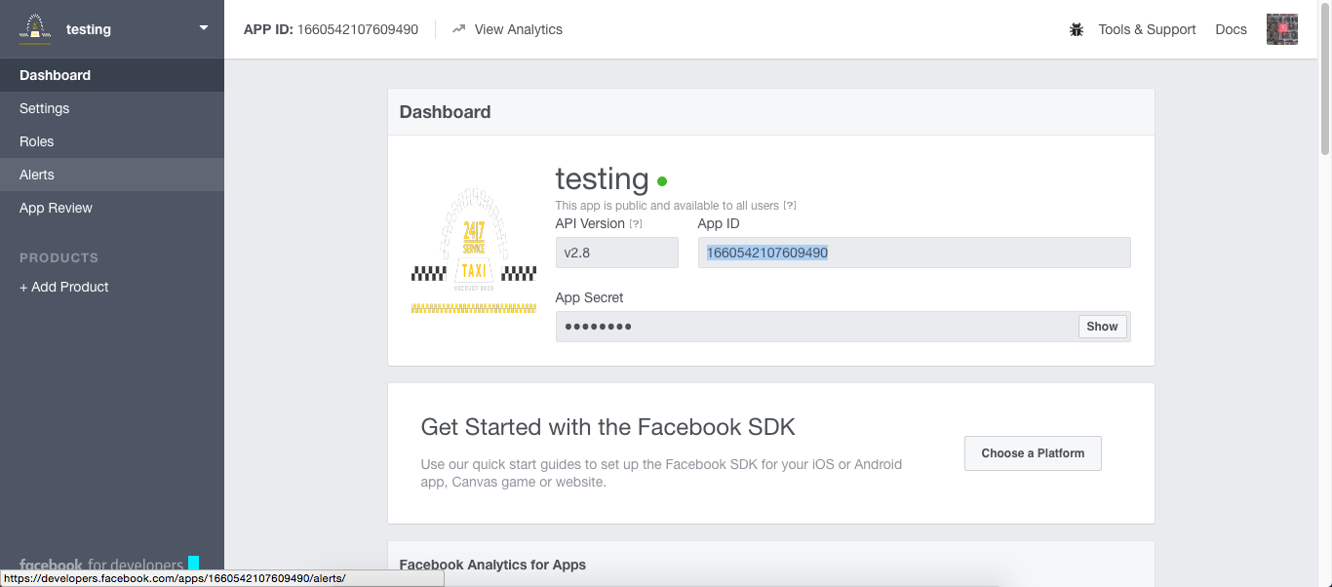

* 1. Copy App Id and paste your string.xml file.

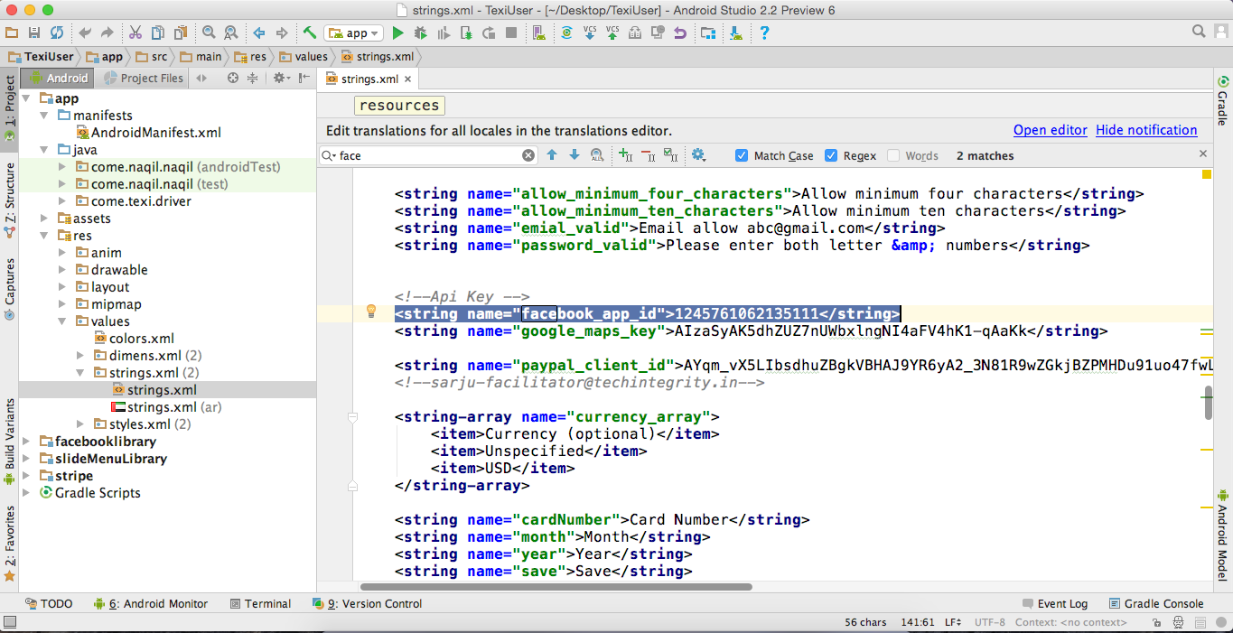

1. Driver App GCM Key can be changed from below file .

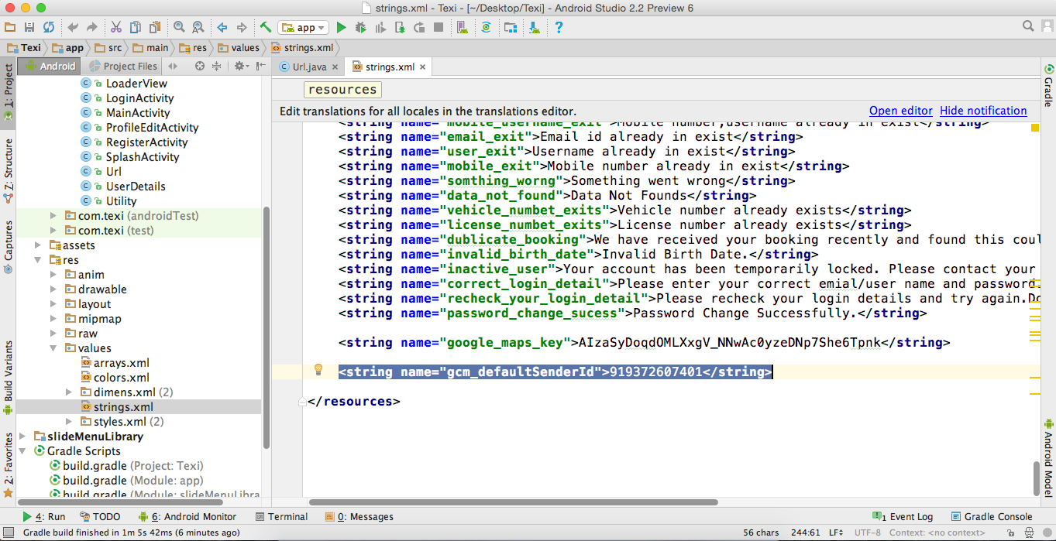

2. Driver App Google Map Key.

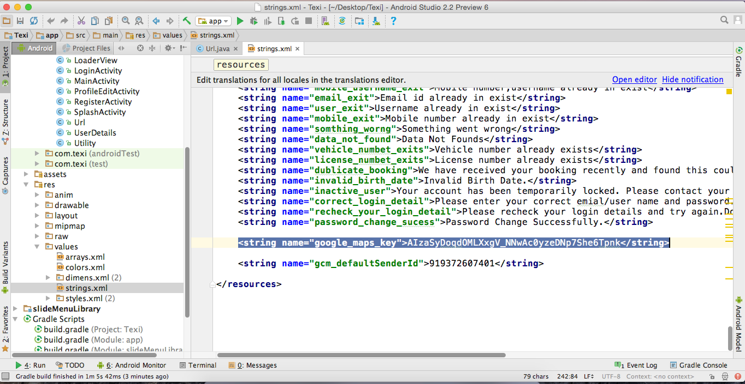

3. User App GCM Key can be changed from below

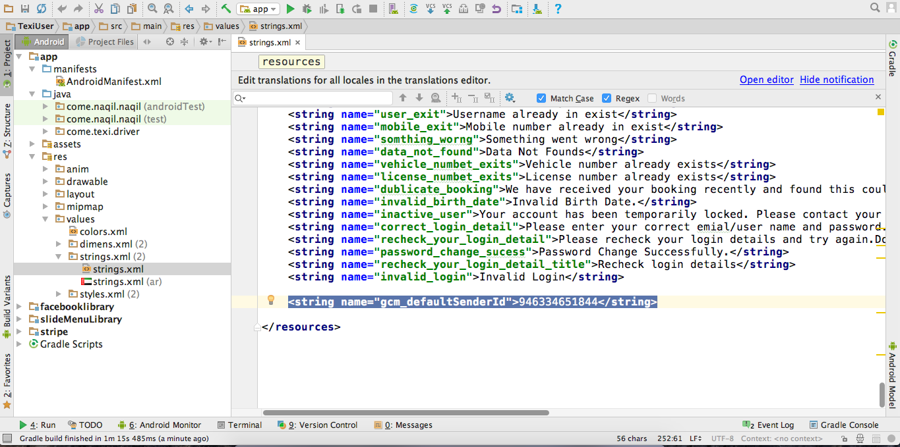

4. User App Google map key can be changed from this file

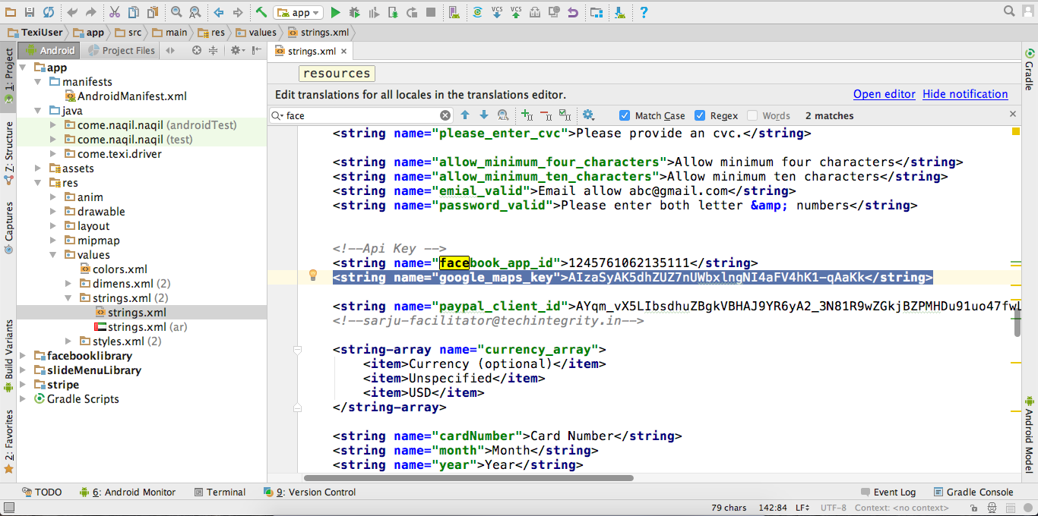

User App Paypal Details can be changed from below screenshot.

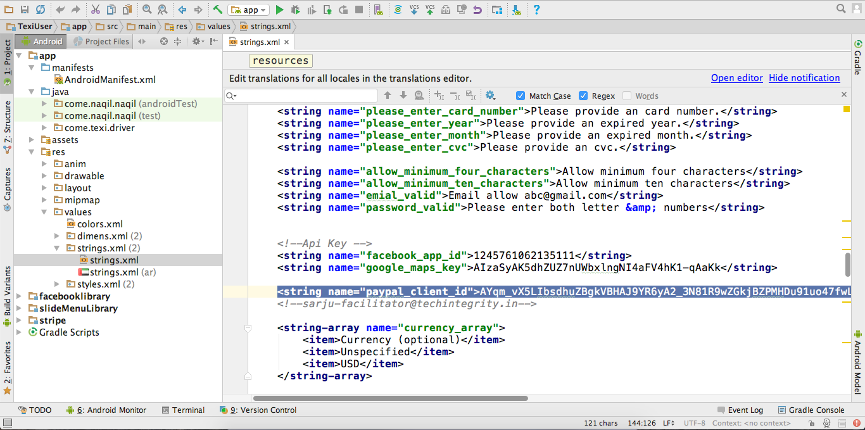

Feel free to revert back with any support or issues

Email : [rupen@techintegrity.in](mailto:rupen@techintegrity.in)

Skype : rupenm

Cell : +91-8866045386